**ASSIGNMENT 1 – PART B**

**CREATING AND DEPLOYING PHOTO ALBUM WEBSITE ONTO A SIMPLE AWS INFRASTRUCTURE**

**COURSE: CLOUD COMPUTING ARCHITECTURE (COS20019)**

Tutorial class: Tuesday, 6.30pm - 8.30pm, BA

Name: Nhat Minh Tran

Student ID: 104082552

Semester 2, 2023

1.1 - VPC

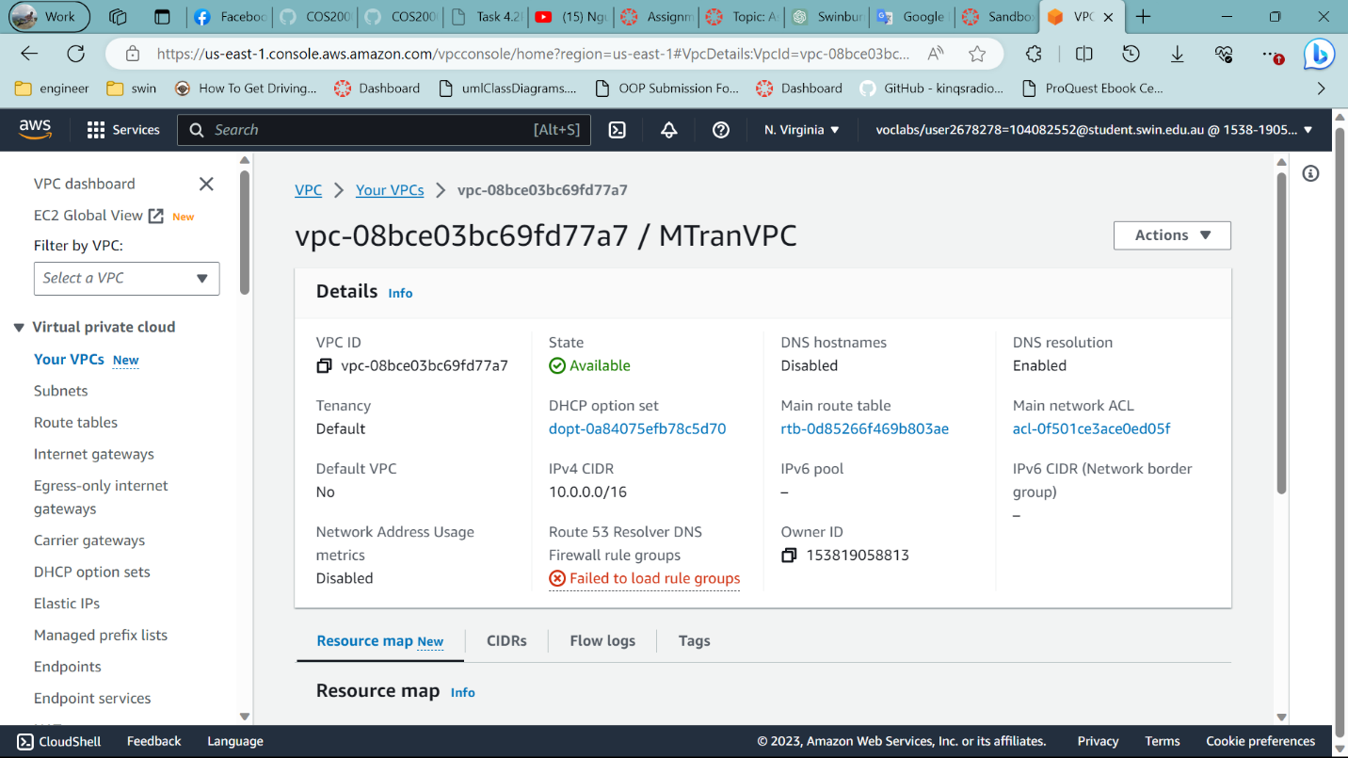

In the first stage, I created a VPC. Secondly, following the diagram in the assignment, I created four subnets in two AZs (two public for connection to IGW and two private subnets for security purposes). IGW is created and attached to VPC, it also associated to public route table.

Create IGW and connect

4 subnets

With 2 AZ

Create Route Table and add IGW to public route table

Resources map with private and public route table

1.2 – Security groups

Three security groups are built with different protocols to allow specific instances.

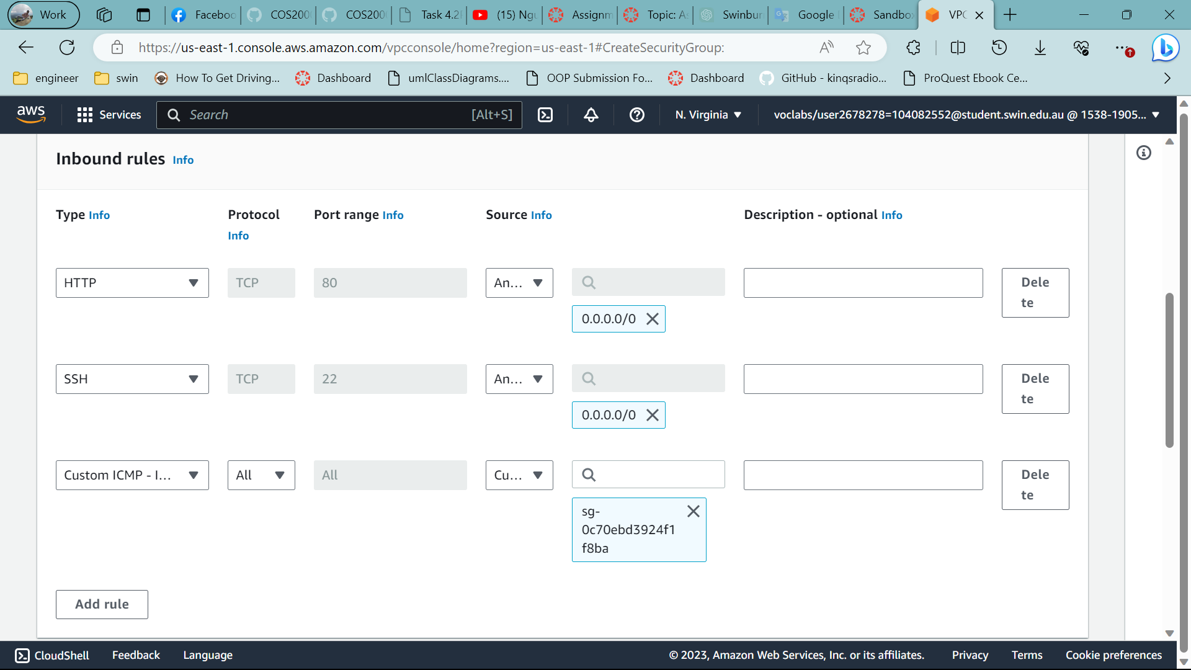

Configure the security group for WebServerSG

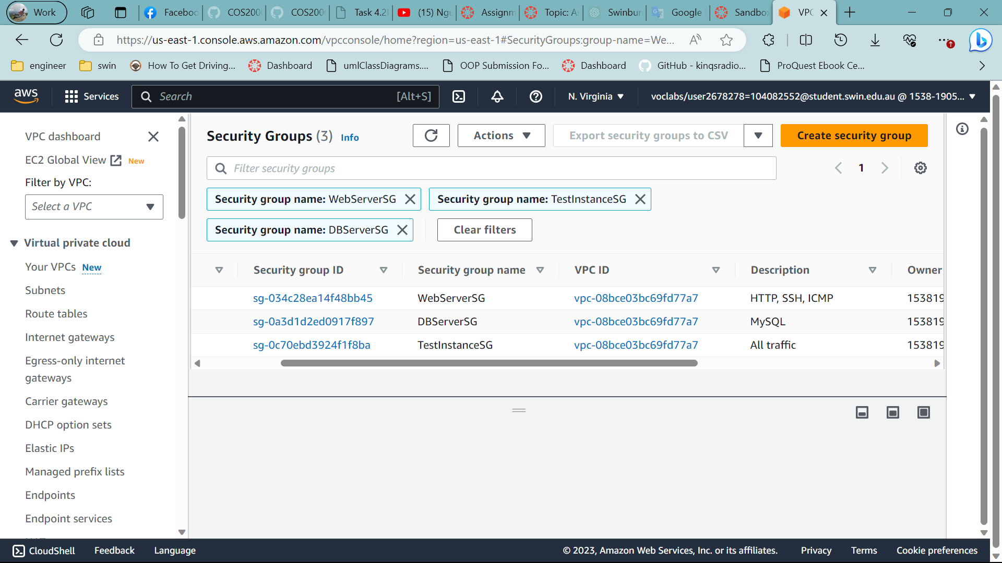

3 security group

1.3 – EC2 virtual machine

In this stage, I created two EC2 instances, a web server instance and a web server instance. The web server instance had PHP/HTML code to run the website. VPC is associated with Elastic Ip so that it is fixed, public IPv4 address does not change if I stop and start the instance.

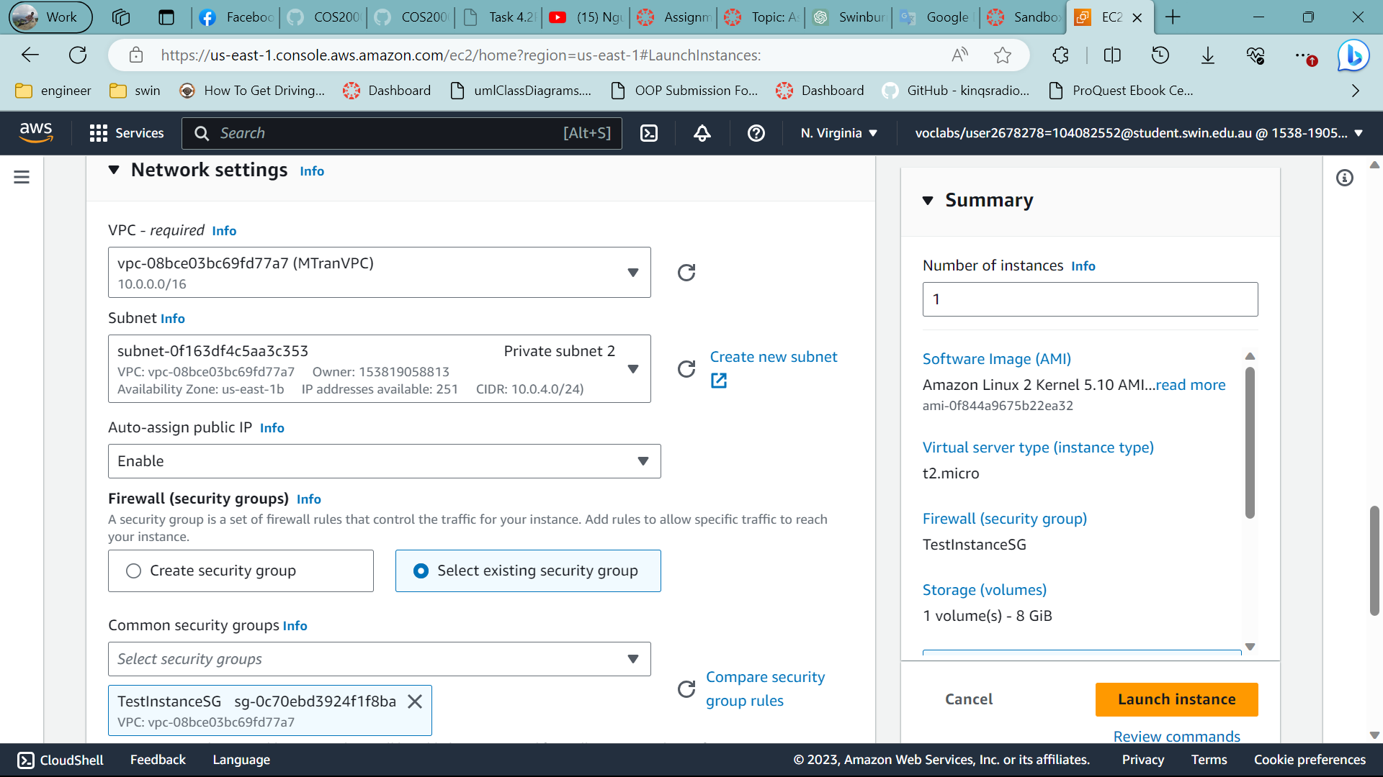

Network settings of EC2

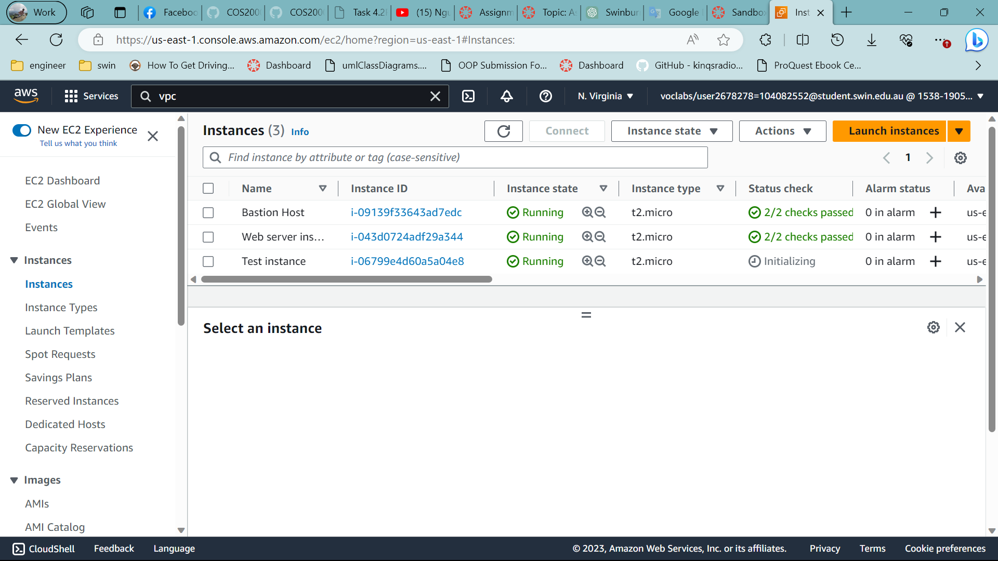

Create 2 ec2

The website for testing

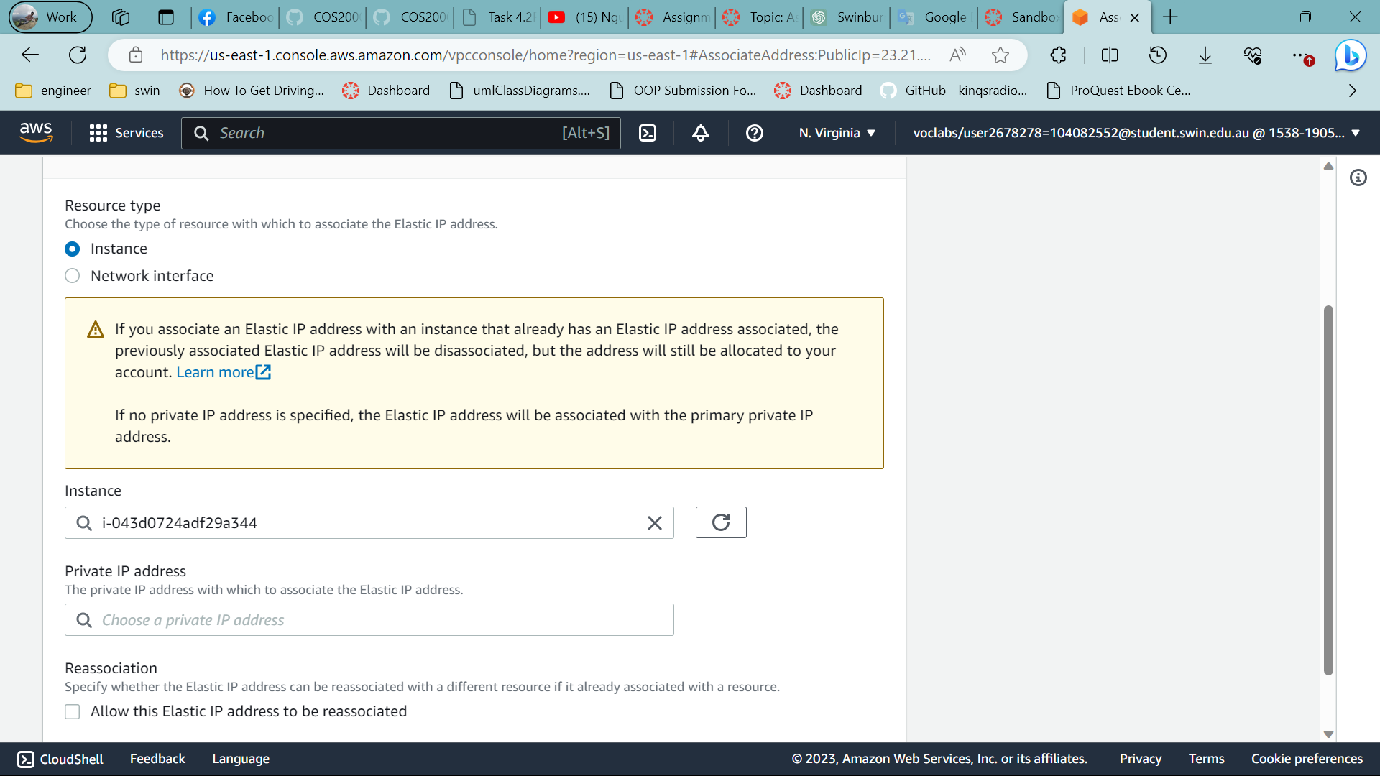

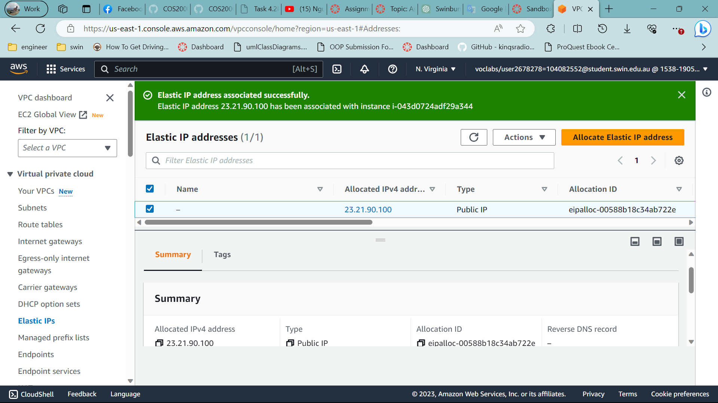

Elastic Ip is now running

1.4 – RDS database instance

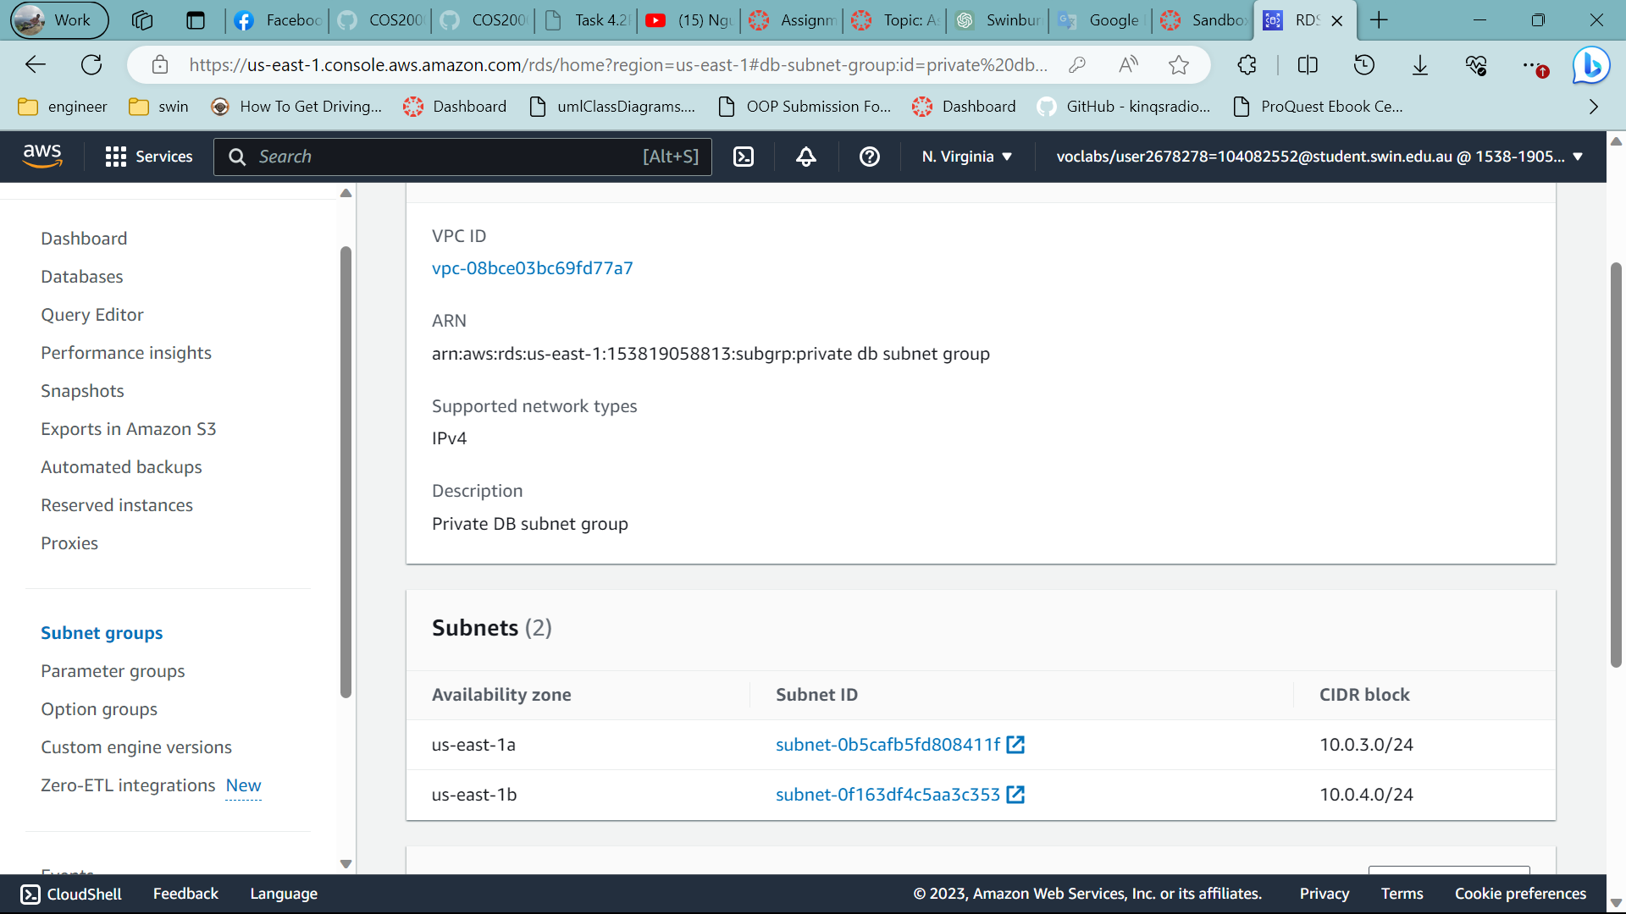

Create subnet group private DB

Mysql

8.0.34

MTran-RDS

MTran

Nhatminh321

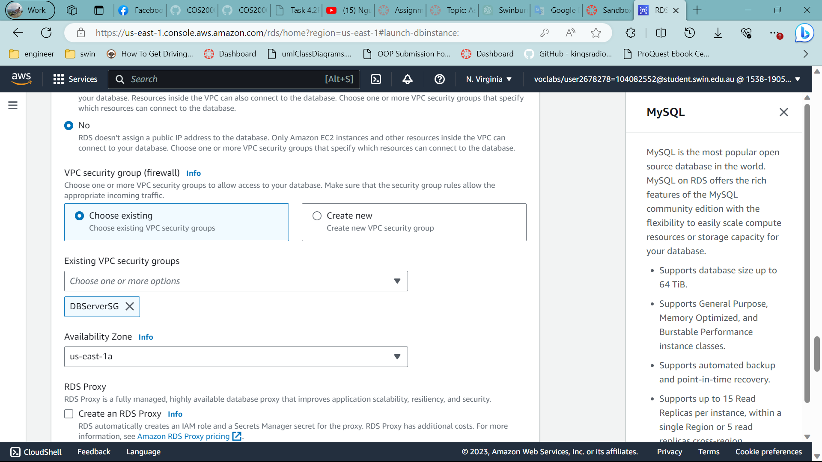

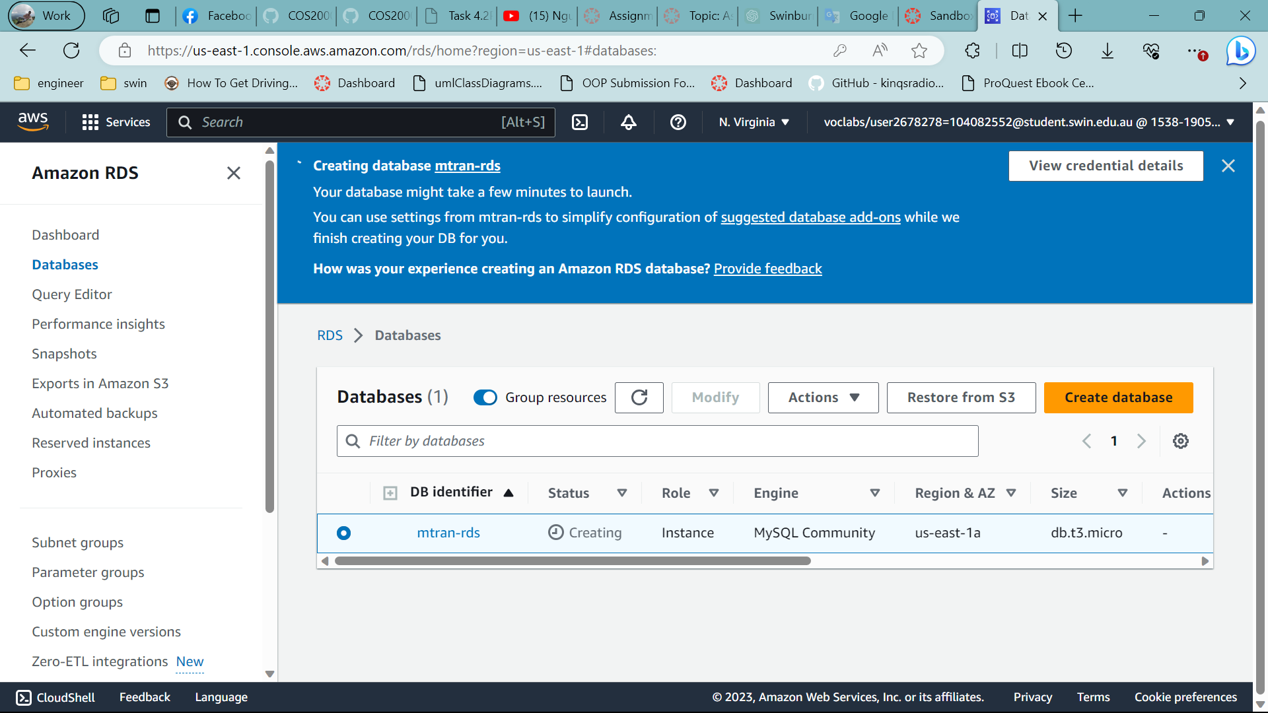

Create DB

Open putty and add ppk

Convert in from puttygen

Ssh -i Minh.pem

[Ec2-user@23.21.90.100](mailto:Ec2-user@23.21.90.100) ip of webserver

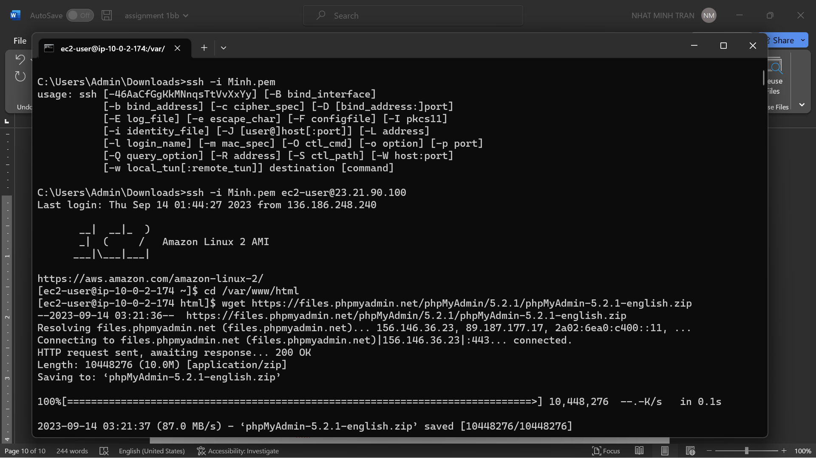

Do the same with the phpadmin and fix the problem

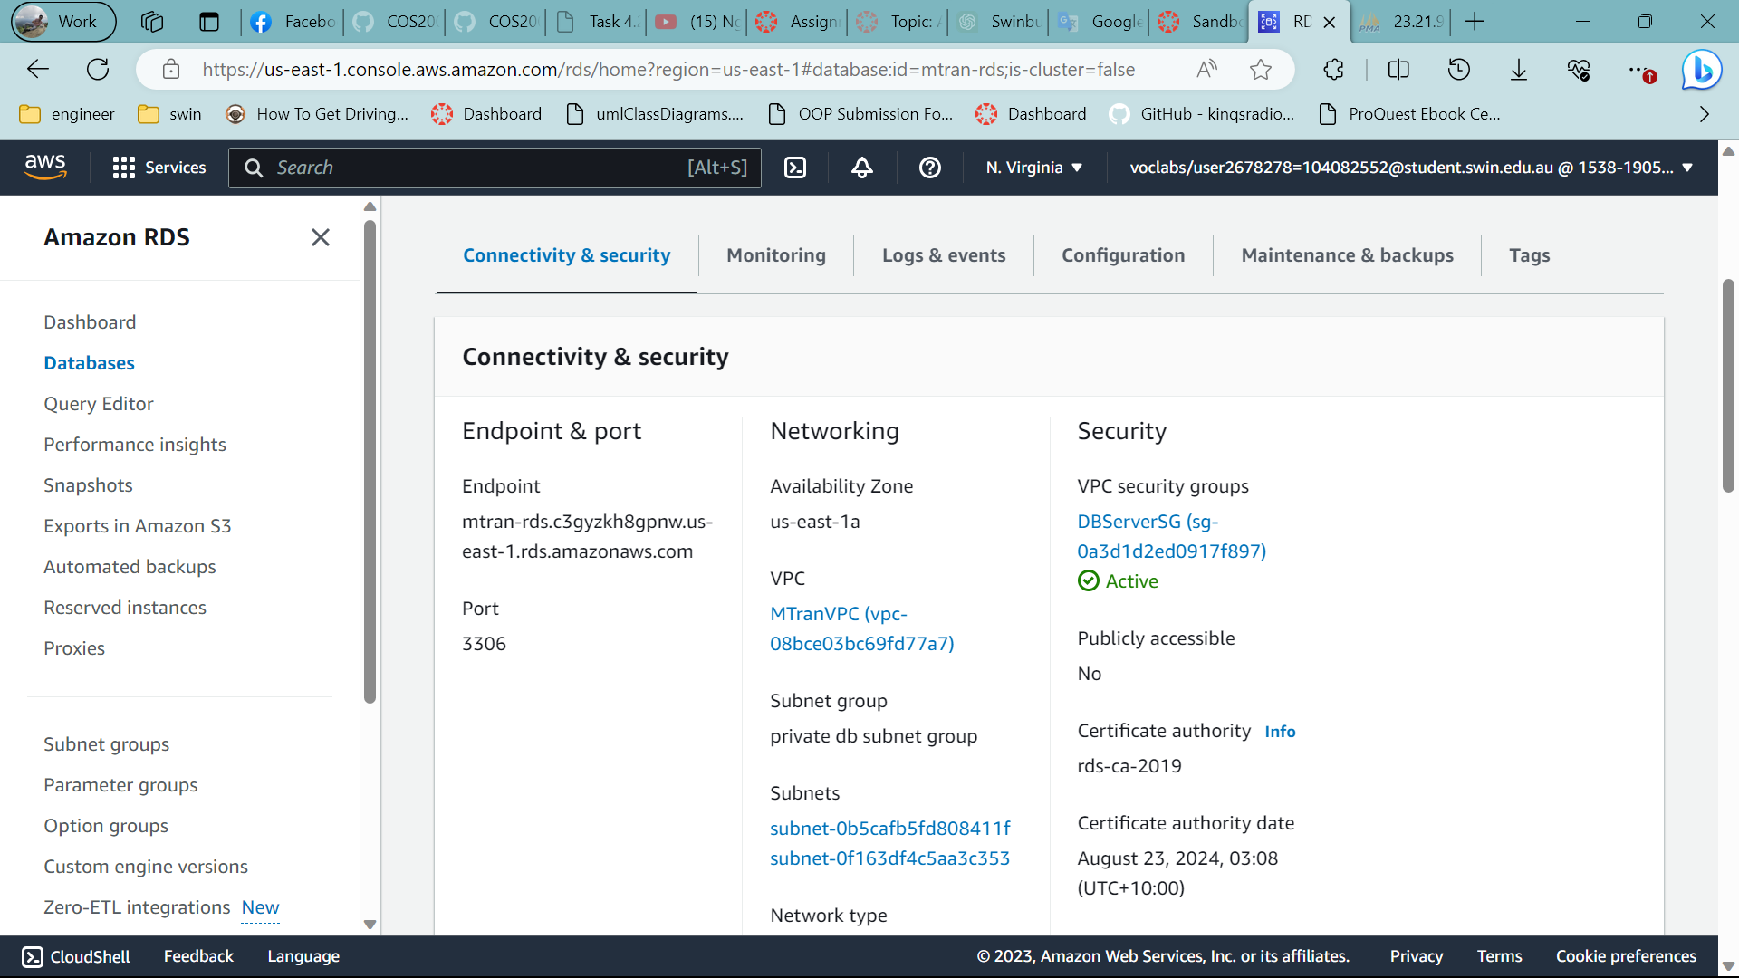

Take the endpoint

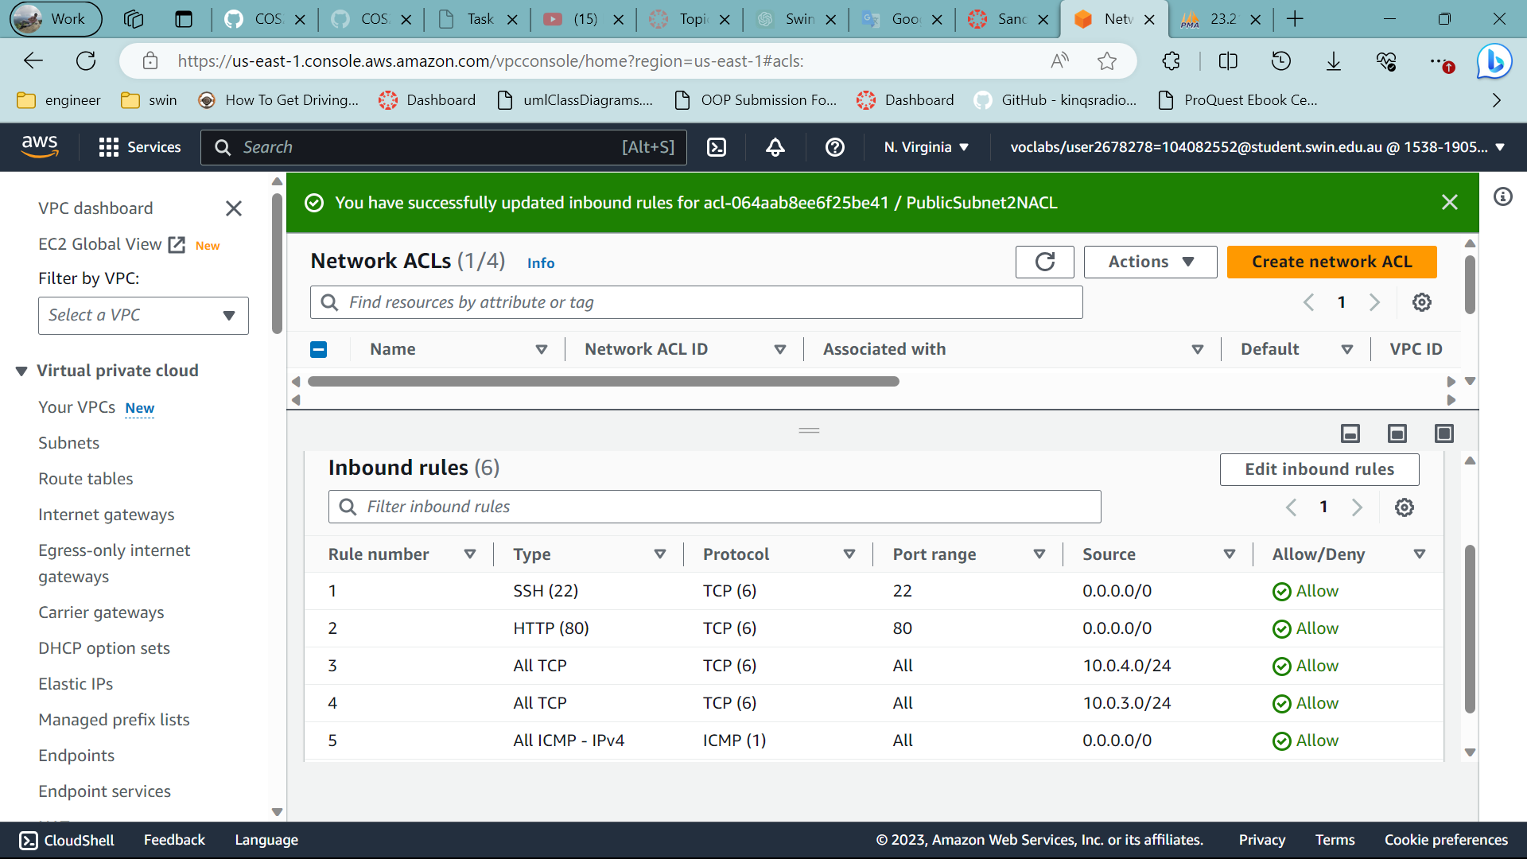

Inbound rules of net acl

Associate to public subnet 2

Outbound rule

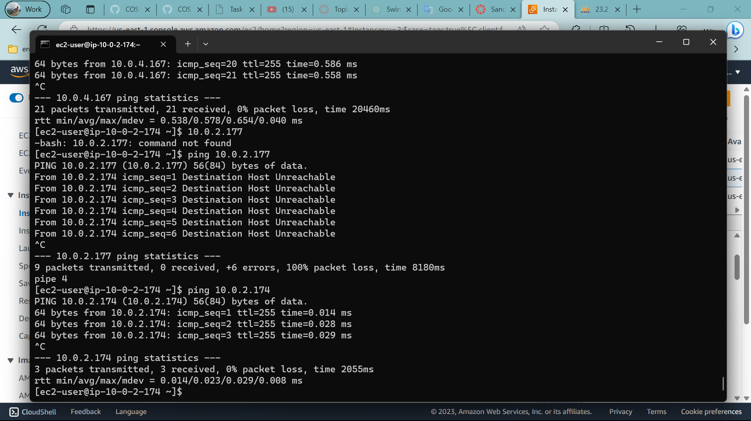

Ping Web server and test instance

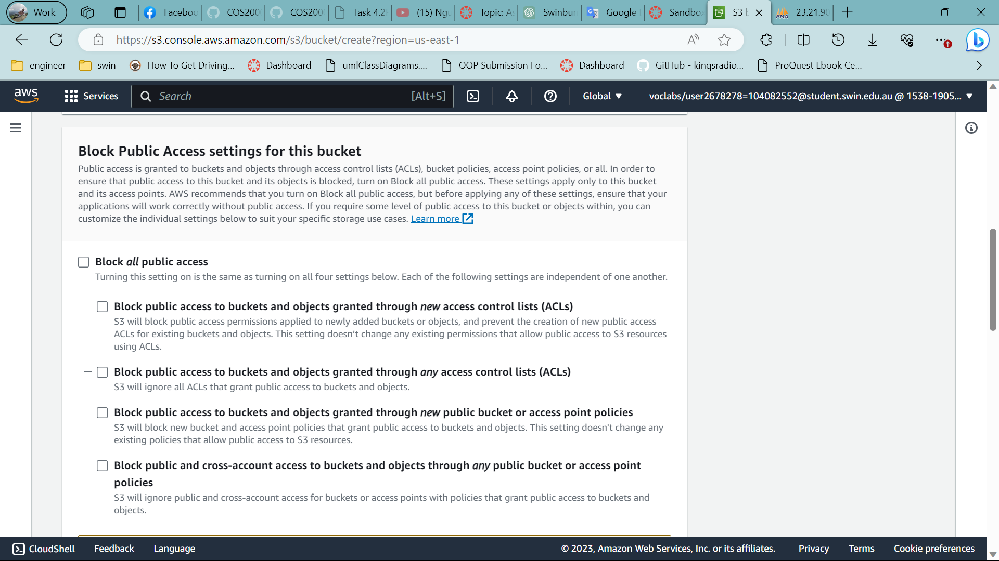

Enable public for s3

{

"Version": "2012-10-17",

"Statement": [

{

"Sid": "ListObjectsInBucket",

"Effect": "Allow",

"Principal": "*",

"Action": "s3:ListBucket",

"Resource": "arn:aws:s3:::mtran"

},

{

"Sid": "AllObjectActions",

"Effect": "Allow",

"Principal": "*",

"Action": "s3:*Object",

"Resource": "arn:aws:s3:::mtran/*"

}

]

}